Analysing The Eighteenth-Century Interior Through Morning

This article will explore the historical social context and elite life of the 18th-century through the content and visual elements of the painting, based on Nicholas Lancret's genre painting *Morning* ***[Figure 1***], from the four times of the day, which was created in February 1741. The genre painting is a popular form of painting in the 18th-century, which expresses some realistic stories by depicting scenes of daily life.

## I. Painting content and visual elements

This painting shows an noble lady meeting with a man in her bedroom. The image centres on the lady, who is seated at a side table, pouring tea for the man. On the other side of the lady was the dressing table, and behind her stood the maid ready to put on her headdress. The woman is dressing, as she sits at the dressing table, wearing naked, informal clothes and is casual, and the man is formal and is probably a guest. In terms of color, the artist used white and pink, which are bright and vivid colors, to depict the two women in this painting. A lot of blues and greens are used in the background and dark areas and decorated with gold. In terms of composition, it expands with the noble lady in the centre of the picture, forming a firm triangular composition. The naked breasts become the centre of vision, indicating the erotic atmosphere of the painting.

## II. Analysis of interior furniture changes and objects

The French aristocracy of the 18th-century would spend their leisure time in luxurious decorated Interiors. The significant features of the furniture of this period were the professionalization of the function, the lightweight and removable sizes to ensure the flexibility of the space arrangement. The elite houses of the 18th-century were designed for comfort and convenience.[1] The nobles began to plan different functional zones in their rooms, for example, the room in this painting has a dressing table for grooming, a side table for tea, and these tables are matched with chairs of different functions next to each other. In the period before Louis XIV, houses were usually designed to show off the status and wealth of their owners, the rooms were mainly public spaces, and the furniture was generally decorated and heavy.[2] The elite of the period of Louis XIV and XV began to focus on life itself, serving the needs of the user, to this purpose they designed furniture that was highly specialized in its functions and easy to move around. In addition, to show off the luxury of the house, the walls of the room are decorated with a series of objects in fixed positions, which have been specifically designed for their location.[3] For instance, the distribution of the decorative paintings in this picture and the wall clocks would be in coordination with the furniture. While the background of the picture is a bed next to the wall, the two decorative paintings placed symmetrically and the height of the wall clocks are matched to the bed.

### 1. Side tables and chairs

The table and chairs in *Morning* are a classic example of 18th-century interior furniture. It is a side table placed next to the bed, with slim legs that make it easy to change position. The desktop is small just enough to hold the tea set. Which means that the table is mainly used for eating and drinking by the bedside and for small socializing in a private space. Side tables for writing and side tables with locking storage were also popular during the same period. As an example, in this small writing table from the collection of the Victoria and Albert Museum in London ***[Figure 2]***, It was made by cabinetmaker Martin Carlin in 1775, and is similar in shape to the tea table in the *Morning*, which is also small and flexible, with a tiny drawer built in for writing implements. The side table in the *Morning* is a dark brown color, and it is clear by the brilliance that it is not just ordinary wood, and may have been lacquered as well. The chairs on the right side where the men sit also keep the same style, both are elegant and small-sized pieces of furniture. The chairs for the ladies on the other side are a little different. The chair that the lady sits has a shorter back, this chair is used with a dresser and the shorter back is for the hair dressing convenience.[4] Overall, the furniture of the 18th-century elite had a more specialized function; each piece of furniture was designed to achieve a specific function, and the lifestyle of the elite revolved around personal comfort and convenience.

### 2. Dressing table

The table in the Morning is covered by an ornate blue cloth, and by the red boxes and other tools on the tabletop, it could be assumed that this is a dressing table. Which was an essential part of the life of the French elite in the 18th-century. The dresser is more complex in structure, incorporating a wide range of make-up items and a larger sized mirror. More details can be found through a dresser at the Victoria and Albert Museum in London ***[Figure 3]***. This table has the combined function of dressing and writing table, with a lot of drawers and cabinets ***[Figure 4]***, inside these drawers will store all kinds of cosmetic bottles, tools and jewellery ***[Figure 5]***. For security and privacy, these drawers and cabinets have locks. During that period, socializing was so prevalent that grooming was not only a process of washing, but an important part of the socialization routine for elite men and women, partly as a sign of respect for the visitors and also as a social program to exchange opinions on fashion.[5] In short, these widely spread dressing tables originated in late 17th century Europe and evolved into social status symbols in the 18th-century due to their beautiful craftsmanship and design.[6]

### 3. Porcelain and Tea

Porcelain from China and Japan played an important role in the lives of the nobility in the 18th-century. Beginning with the involvement of Chinese businessmen in global trade, European elites began to buy imported porcelain. On the table in the *Morning* is the porcelain tea set, which means that in this painting, the tea set is used as a kind of daily tableware, so it can be inferred that this lady is a member of the aristocratic class. At social events in the 18th-century, porcelain symbolized status and taste. On the other hand there was also a close connection with power. Chinese and Japanese porcelain entered Europe through the import trade, and from the 17th century forward, people had very limited ways of purchasing porcelain, which could be acquired through social connections on the one hand, such as gifts exchanged between nobles or inherited from relatives on the other.[7] On the other hand, purchases were made through “merchants”. [8]As a result, the complexity of the production methods and the scarcity of quantities made authentic porcelain a symbol of status and privilege in 18th-century Europe. In addition to tea sets, tea as an imported beverage was a sign of elite leisure. In the late 17th and early 18th centuries, the East India Company and Chinese officials developed trade and imported a variety of luxury goods, including tea.[9] Demand for tea continued to grow in the eighteenth century, with more and more of the elite enjoying tea as a decent leisure activity.[10] Overall, the ceramic tea sets and tea leaves are imported luxuries, and *Morning*'s portrayal of a social event revolving around drinking tea perfectly portrays an aristocratic lady.

## III. Construction of the elite class

### 1. Luxury goods and transactions

The luxury goods highlighted in *Morning* can be categorized into imported goods and custom-made furniture, which were two important types of luxury goods in the life of the French aristocracy. Porcelain is an example of imported luxury, the definition of which depends on the scarcity of the goods, and is also influenced by the attitudes and tastes of the aristocracy. For example, porcelain was often regarded as a valuable gift in European diplomacy.[11] From the beginning of the 1700s to the end of the 1800s, the East India Company imported 43 million pieces of porcelain from China.[12] This led to a massive financial outflow to Asia. Driven by the mercantilism of the European governing class, a few European countries began to establish their own porcelain factories and served the court institutions as part of the state apparatus.[13] In short, the fine decoration and complex craftsmanship of porcelain was the basis of its status as a luxury item, and the attention and admiration of the rulers pushed the status of porcelain to an even higher level.

The second category of luxury goods was furniture that was specifically designed to emphasize aesthetics. In eighteenth-century Europe, luxury tradesmen, or “merchants”, played an important role in the manufacture of furniture, coordinating craftsmen from different sectors to produce furniture, such as multifunctioning dressers. They also make or imitate lacquer furniture using lacquer imported from China or Japan, and have mastered the process of reorganization to modify imported furniture. For instance, they commission cabinet makers to add lacquer decorations to their cabinets***[Figure 6]***.[14]

There are two reasons for the prosperity of the luxury trading market in the 18th-century. Firstly, this period was an important stage in the development of world trade, and Chinese merchants were involved in the global trade during this period, with luxury goods such as porcelain and tea being sold to England and France by sea. The East India Company realized a large-scale import trade, and large quantities of goods continued to reach the European market in a steady stream.[15] Secondly, merchants promoted the trade of luxury goods within the aristocracy. Merchants connected the demand and supply sides and realized the nobility's higher pursuit of luxury goods through customization. Overall, scarce imported goods and customized and exquisite furniture built the daily life of the rich class in that period. The trade of luxury goods also prospered and improved gradually with the needs of the rich people.

### 2. Elite leisure and identity construction

The Morning painting depicts two activities: grooming and drinking tea. There are important similarities between these two activities, which are rituals and constraints, with many regulated rituals to shape the appearance of the elite and several decorations and objects to constrain their behavior.[16] From tea tables to dressers, tea sets and tea drinks, these exquisite luxuries build an elite environment and luxurious atmosphere. Those who are accomplishing these leisure activities will naturally have the demeanor of the aristocracy. Another more direct reason is that the medium of elite leisure is luxury goods, such as imported porcelain tea sets and imported tea and sugar. These luxuries were difficult to obtain and required special channels and costly fees. Thus, the high cost of living of the aristocracy and the elite was one of the means of maintaining a gap with the other classes.

## IV. Conclusion

*Morning* recreates the daily life of the nobles through vivid scenes. There is perhaps a degree of exaggeration in the portrayal of the erotic parts, which is an artistic expression. However, the portrayal of the environment still represents the living style of the aristocrats at that time. This paintings is not only of artistic and aesthetic value, but also an important material for the study and understanding of 18th-century social customs. This article explores the types and development of mainstream luxury goods in eighteenth-century Europe by analyzing interior furniture and objects. It explains the reasons for the popularity of luxury goods in aristocratic circles and the relationship with elite status.

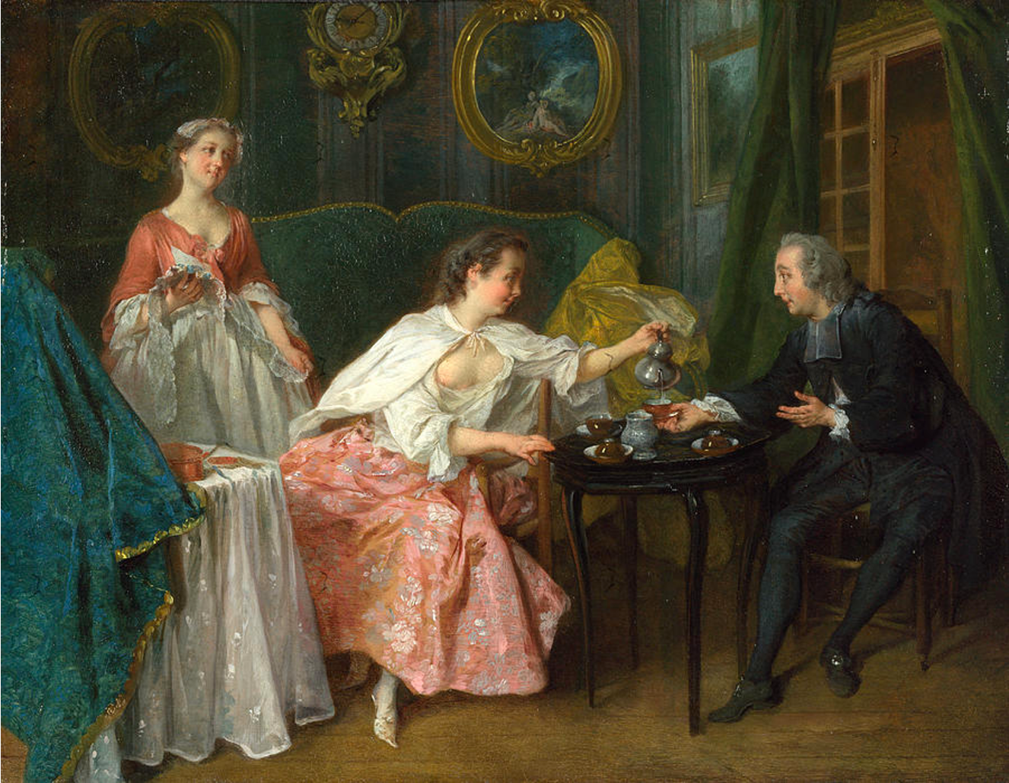

Figure 1. Nicholas Lancret, Morning, from the Four times of the day, 1741

National Gallery London

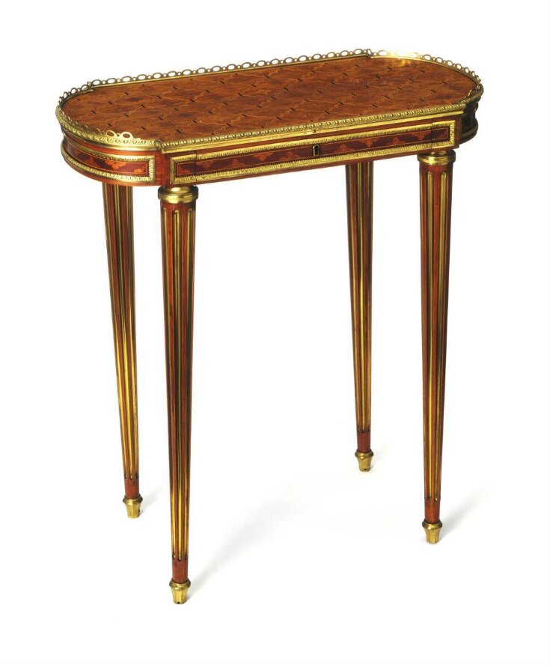

Figure 2. Table, Martin Carlin, 1775, Paris

Victoria and Albert Museum

Figure 3&4. Cylinder Desk, 1776-1780, France

Victoria and Albert Museum

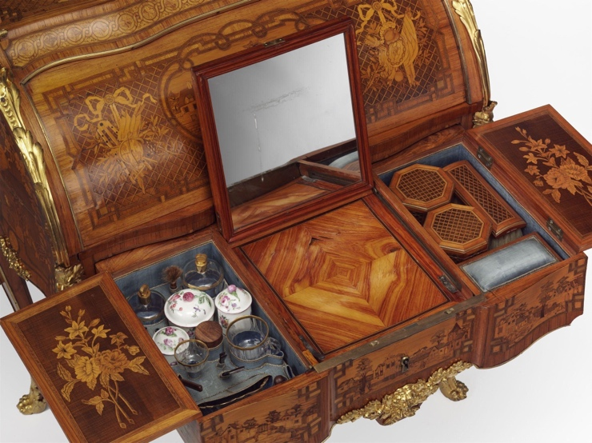

Figure 5. Cylinder Desk, 1776-1780, France

Victoria and Albert Museum

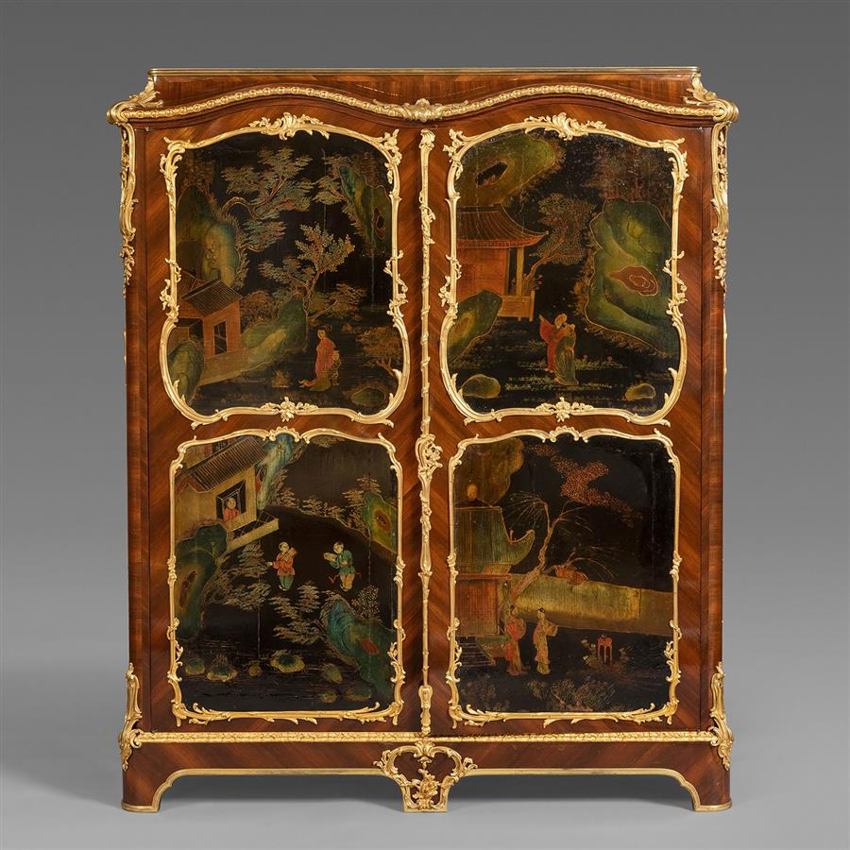

Figure 6. A Louis XV Style Gilt Bronze and Coromandel Lacquer Mounted Kingwood Parquetry Mahogany Armoire à Doucine, After the Model by Bernard II van Risenburgh

Paris, France, 1870, Height: 168 cm, Width: 145 cm, Depth: 43 cm

# Bibliography

Berg, Maxine. “In Pursuit of Luxury: Global History and British Consumer Goods in the Eighteenth Century.” *Past & Present*, no. 182 (2004): 85–142. <https://www.jstor.org/stable/3600806>.

Bremer-David, Charissa, and J. Paul Getty Museum. *Paris: Life & Luxury in the Eighteenth Century*. *Google Books*. Getty Publications, 2011. <https://books.google.com.au/books?hl=zh-CN&lr=&id=fqG_taxCIfgC&oi=fnd&pg=PP1&dq=Paris:+Life+%26+Luxury+in+the+Eighteenth+Century&ots=6RWLUkqVsv&sig=rLKWniznDXjQrInW7qGRbsrd0ZU&redir_esc=y#v=onepage&q=Paris%3A%20Life%20%26%20Luxury%20in%20the%20Eighteenth%20Century&f=false>.

Cassidy-Geiger, Maureen. *Fragile Diplomacy : Meissen Porcelain for European Courts Ca. 1710-63*. New Haven: Published For The Bard Graduate Center For Studies In The Decorative Arts, Design, And Culture, New York, By Yale University Press, 2007.

Cite galleries. “A Louis XV Style Gilt Bronze and Coromandel Lacquer Mounted Kingwood Parquetry Mahogany Armoire à Doucine.” Citegalleries.com, 2024. <https://www.citegalleries.com/42/481>.

Ferguson, Patricia. “‘“Japan China” Taste and Elite Ceramic Consumption in 18th-Century England: Revising the Narrative.’” *Www.academia.edu* 23, no. 1 (2016). <https://www.academia.edu/7181167/_Japan_China_taste_and_elite_ceramic_consumption_in_18th_century_England_revising_the_narrative_>.

Hellman, Mimi. “Furniture, Sociability, and the Work of Leisure in Eighteenth-Century France.” *Eighteenth-Century Studies*32, no. 4 (1999): 415–45. <https://www.jstor.org/stable/30053926>.

Jane, Adlin. *Vanities: Art of the Dressing Table*. *Google Books*. Metropolitan Museum of Art, 2013. <https://books.google.com.au/books?hl=zh-CN&lr=&id=QvopAgAAQBAJ&oi=fnd&pg=PA2&dq=Vanitiesart+of+the+dressing+table&ots=4q6vusHx2_&sig=HLSRvnszmdOUYsaVq5rj8eqbzuU&redir_esc=y#v=onepage&q=Vanitiesart%20of%20the%20dressing%20table&f=false>.

Martin Carlin. “Table.” Victoria & Albert Museum, 1775. <https://collections.vam.ac.uk/item/O120857/table-martin-carlin/>.

Martin, Matthew. “Porcelain and Power: The Meaning of S{\`E}Vres Porcelain in Ancien.” In *The Versailles Effect: Objects, Lives, and Afterlives of the Domaine*, 77. Bloomsbury Publishing USA, 2020.

Smith, Woodruff D. “Complications of the Commonplace: Tea, Sugar, and Imperialism.” *Journal of Interdisciplinary History*23, no. 2 (1992): 259. <https://doi.org/10.2307/205276>.

Unknown. “Cylinder Desk.” Victoria & Albert Museum, 1776. <https://collections.vam.ac.uk/item/O152802/cylinder-desk-unknown/>.

Verlet, Pierre. “Le Commerce Des Objets d’Art et Les Marchands Merciers: à Paris Au XVIIIe Siècle.” *Annales. Histoire, Sciences Sociales* 13, no. 1 (1958): 10–29. <https://www.jstor.org/stable/27579924>.

www.nationalgallery.org.uk. “Nicolas Lancret | the Four Times of Day: Morning | NG5867 | National Gallery, London.” Accessed June 1, 2024. <https://www.nationalgallery.org.uk/paintings/nicolas-lancret-the-four-times-of-day-morning>.

1. Mimi Hellman, “Furniture, Sociability, and the Work of Leisure in Eighteenth-Century France,” *Eighteenth-Century Studies* 32, no. 4 (1999): 415–45, <https://www.jstor.org/stable/30053926>.
2. Mimi Hellman, “Furniture, Sociability, and the Work of Leisure in Eighteenth-Century France,” *418*.
3. Mimi Hellman, “Furniture, Sociability, and the Work of Leisure in Eighteenth-Century France,” *418*.
4. Mimi Hellman, “Furniture, Sociability, and the Work of Leisure in Eighteenth-Century France,” *419.*
5. Mimi Hellman, “Furniture, Sociability, and the Work of Leisure in Eighteenth-Century France,” *427*.
6. Adlin Jane, Vanities: Art of the Dressing Table, Google Books (Metropolitan Museum of Art, 2013), 8.
7. Patricia Ferguson, “‘Japan China’ Taste and Elite Ceramic Consumption”.
8. Mimi Hellman, “Furniture, Sociability, and the Work of Leisure in Eighteenth-Century France,” *427*.
9. Maxine Berg, “In Pursuit of Luxury: Global History and British Consumer Goods in the Eighteenth Century,” Past & Present, no. 182 (2004): 85–142, <https://www.jstor.org/stable/3600806>.
10. Woodruff D. Smith, “Complications of the Commonplace: Tea, Sugar, and Imperialism,” *Journal of Interdisciplinary History* 23, no. 2 (1992): 259, <https://doi.org/10.2307/205276>.
11. Matthew Martin, “Porcelain and Power: The Meaning of S{\`E}Vres Porcelain in Ancien,” in *The Versailles Effect: Objects, Lives, and Afterlives of the Domaine* (Bloomsbury Publishing USA, 2020), 77.
12. Maxine Berg, “In Pursuit of Luxury”.
13. Matthew Martin, “Porcelain and Power,” 77.
14. Pierre Verlet, “Le Commerce Des Objets d’Art et Les Marchands Merciers: à Paris Au XVIIIe Siècle,” Annales. Histoire, Sciences Sociales 13, no. 1 (1958): 10–29, <https://www.jstor.org/stable/27579924>.
15. Patricia Ferguson, “‘Japan China’ Taste and Elite Ceramic Consumption”.
16. Mimi Hellman, “Furniture, Sociability, and the Work of Leisure in Eighteenth-Century France,” *431*.